Q1) Analytical Modelling

Part a)

Reluctance of the system is derived according to angle of the rotor.

For θ = 0 rad;

$$Req= \frac{2*air_gap_small}{µ_{0}*\frac{2*arcsin\left(\frac{7.5}{12}\right)}{2*π}*2*π*r_{large}*core_depth}$$

For θ > 0 and θ <2\*arcsin(7.5/12);

$$R1= \frac{2*air_gap_small}{µ_{0}*\frac{2*arcsin\left(\frac{7.5}{12}\right)-θ}{2*π}*2*π*r_{large}*core_depth}$$

$$R2= \frac{2*air_gap_large}{µ_{0}*\frac{θ}{2*π}*2*π*r_{small}*core_depth}$$

$$Req= \frac{R1*R2}{R1+R2}$$

For θ >2\*arcsin(7.5/12) and θ <(π-2\*arcsin(7.5/12))

$$Req= \frac{2*air_gap_large}{µ_{0}*2*\frac{\arcsin\left(\frac{7.5}{12}\right)}{2*π}*2*π*r_{small}*core_depth}$$

For θ >(π-2\*arcsin(7.5/12))

$$R1= \frac{2*air_gap_small}{µ_{0}*\frac{2*arcsin\left(\frac{7.5}{12}\right)+θ-π}{2*π}*2*π*r_{large}*core_depth}$$

$$R2= \frac{2*air_gap_large}{µ_{0}*\frac{π-θ}{2*π}*2*π*r_{small}*core_depth}$$

$$Req= \frac{R1*R2}{R1+R2}$$

Inductances can be calculating according to reluctances by using following formula;

$$L= \frac{N^{2}}{Req}$$

Based on these formulas, reluctance and inductance of the system is calculated by using MATLAB and results can be seen in Figure 1 and 2 respectively.

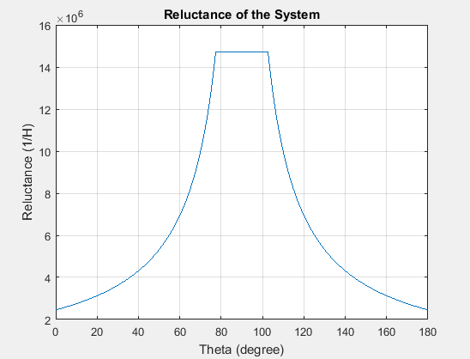

Figure 1

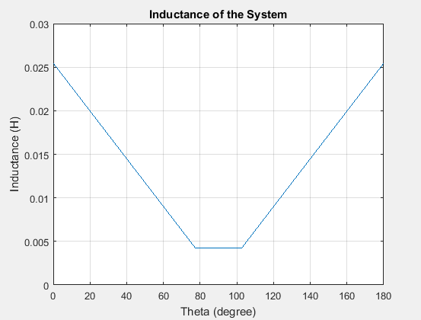

Figure 2